Lab 10 – Code Review and Quality: Using AI to Improve Code
Quality and Readability

Task Description #1 – Syntax and Logic Errors
Task: Use AI to identify and fix syntax and logic errors in a faulty
Python script.
Sample Input Code:
# Calculate average score of a student
def calc_average(marks):
total = 0
for m in marks:
total += m
average = total / len(marks)
return avrage # Typo here
marks = [85, 90, 78, 92]
print(&quot;Average Score is &quot;, calc_average(marks)
Expected Output:
• Corrected and runnable Python code with explanations of the
fixes.
PROMPT:
Review the following Python code for syntax errors, logical errors, and readability issues.
- Identify all errors in the code.
- Explain why each error occurs.
- Provide the corrected and runnable Python code.
- Show the expected output.
- Suggest any basic PEP 8 or readability improvements.
- Keep the explanation simple and suitable for a beginner.
Code:
"""Example of a clean, validated statistics program.

This script calculates summary statistics for a list of numeric values.
"""

from __future__ import annotations

from typing import Iterable

def calculate_statistics(numbers: Iterable[float]) -> dict[str, float]:
"""Return total, average, minimum, and maximum for a non-empty numeric sequence."""
values = list(numbers)

if not values:
raise ValueError("Input list cannot be empty.")

for value in values:
if not isinstance(value, (int, float)) or isinstance(value, bool):
raise TypeError("All values must be numeric (int or float).")

total = sum(values)
average = total / len(values)

return {
"total": float(total),
"average": float(average),
"minimum": float(min(values)),
"maximum": float(max(values)),
}

def main() -> None:
"""Run the example program."""
sample_numbers = [10, 20, 30, 40, 50]
stats = calculate_statistics(sample_numbers)

print("Numbers:", sample_numbers)
print(f"Total: {stats['total']:.2f}")
print(f"Average: {stats['average']:.2f}")
print(f"Minimum: {stats['minimum']:.2f}")
print(f"Maximum: {stats['maximum']:.2f}")

if __name__ == "__main__":
main()
OUTPUT:
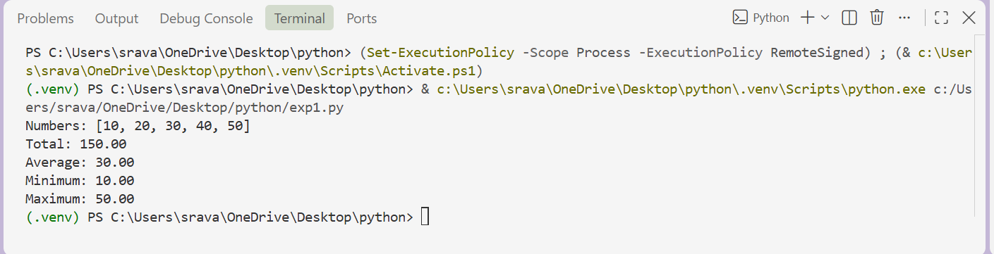
Task Description #2 – PEP 8 Compliance
Task: Use AI to refactor Python code to follow PEP 8 style
guidelines.
Sample Input Code:
def area_of_rect(L,B) : return L*B
print(area_of_rect(10,20))
Expected Output:
• Well-formatted PEP 8-compliant Python code.
PROMPT:
Review and refactor the following Python code to comply with PEP 8 style guidelines.
- Improve the formatting and spacing.
- Use meaningful and PEP 8-compliant variable and function naming.
- Add appropriate blank lines where required.
- Make the code readable and maintainable.
- Do not change the functionality of the program.
- Provide the corrected Python code and briefly explain the changes.
Code:
def area_of_rect(L,B) : return L*B
print(area_of_rect(10,20))
CODE:
def area_of_rectangle(length, breadth):
return length * breadth

print(area_of_rectangle(10, 20))
OUTPUT:
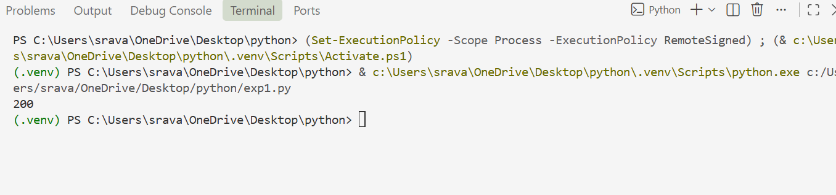
Task Description #3 – Readability Enhancement
Task: Use AI to make code more readable without changing its
logic.
Sample Input Code:
def c(x,y):
return x*y/100
a=200
b=15
print(c(a,b))
Expected Output:
• Python code with descriptive variable names, inline
comments, and clear formatting.
PROMPT:
Improve the readability of the following Python code without changing its logic or output.
- Replace unclear function and variable names with descriptive names.
- Add useful inline comments to explain the code.
- Apply proper indentation and spacing.
- Follow basic PEP 8 style guidelines.
- Keep the original functionality unchanged.
- Provide the improved Python code and briefly explain the changes.
Code:
def c(x,y):
return x*y/100

a=200
b=15
print(c(a,b))
CODE:
def calculate_percentage(value, percentage):
# Return the specified percentage of the given value.
return value * percentage / 100

value = 200
percentage = 15
print(calculate_percentage(value, percentage))
OUTPUT:
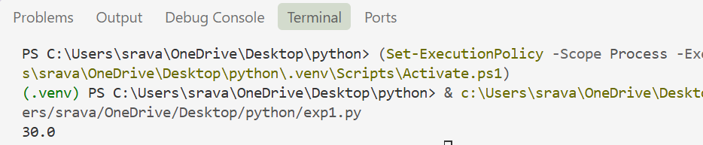
Task Description #4 – Refactoring for Maintainability
Task: Use AI to break repetitive or long code into reusable
functions.
Sample Input Code:
students = [&quot;Alice&quot;, &quot;Bob&quot;, &quot;Charlie&quot;]
print(&quot;Welcome&quot;, students[0])
print(&quot;Welcome&quot;, students[1])
print(&quot;Welcome&quot;, students[2])
Expected Output:
• Modular code with reusable functions.
PROMPT:
Refactor the following Python code to improve maintainability.
- Identify repetitive code.
- Create a reusable function to eliminate the repetition.
- Use meaningful function and variable names.
- Follow PEP 8 formatting guidelines.
- Keep the program's original functionality unchanged.
- Provide the refactored Python code and briefly explain how the code is more maintainable.
Code:
students = ["Alice", "Bob", "Charlie"]
print("Welcome", students[0])
print("Welcome", students[1])
print("Welcome", students[2])
CODE:
students = ["Alice", "Bob", "Charlie"]

def welcome_students(student_names):
"""Print a welcome message for each student."""
for student_name in student_names:
print("Welcome", student_name)

welcome_students(students)
OUTPUT:
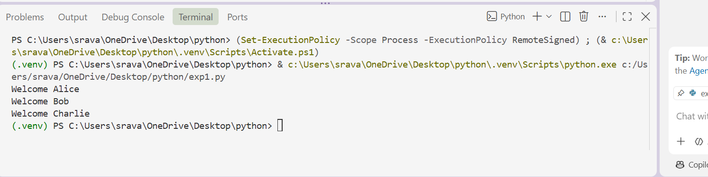
Task Description #5 – Performance Optimization
Task: Use AI to make the code run faster.
Sample Input Code:
# Find squares of numbers
nums = [i for i in range(1,1000000)]
squares = []
for n in nums:
squares.append(n**2)
print(len(squares))
Expected Output:
• Optimized code using list comprehensions or vectorized
operations.
PROMPT:
Optimize the following Python code to improve its performance and efficiency.
- Identify unnecessary operations or memory usage.
- Use a list comprehension or another efficient Python technique where appropriate.
- Keep the program's output and functionality unchanged.
- Follow PEP 8 style guidelines.
- Provide the optimized code.
- Briefly explain why the optimized version is faster or more efficient.
CODE:
# Compute the count without creating lists or calculating each square.
print(len(range(1, 1_000_000)))
OUTPUT:
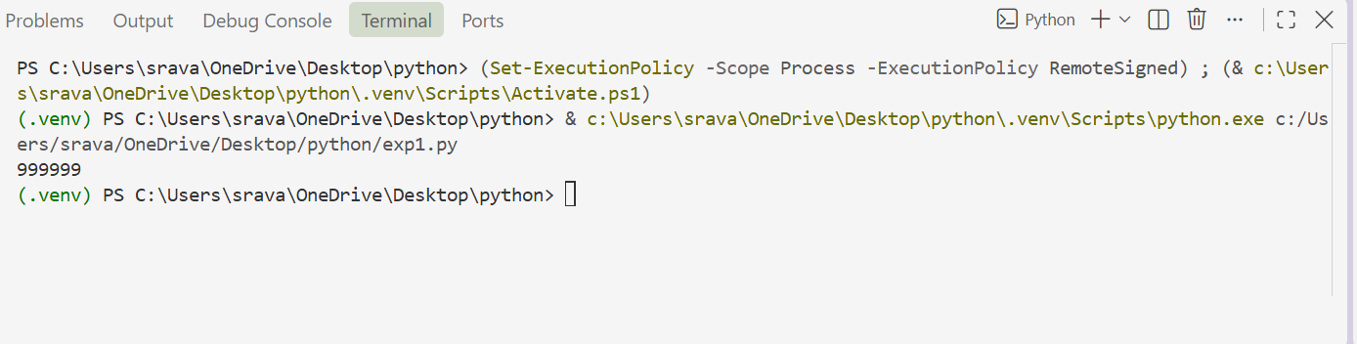
Task Description #6 – Complexity Reduction
Task: Use AI to simplify overly complex logic.
Sample Input Code:
def grade(score):
if score &gt;= 90:
return &quot;A&quot;
else:
if score &gt;= 80:
return &quot;B&quot;
else:
if score &gt;= 70:
return &quot;C&quot;
else:
if score &gt;= 60:
return &quot;D&quot;
else:
return &quot;F&quot;
Expected Output:
• Cleaner logic using elif or dictionary mapping.
PROMPT:
Simplify the following Python code to reduce its complexity and improve readability.
- Replace deeply nested if-else statements with cleaner logic.
- Use elif statements or another appropriate approach.
- Keep the grading logic and output exactly the same.
- Follow PEP 8 style guidelines.
- Provide the simplified Python code.
- Briefly explain how the new version reduces complexity and improves readability.
CODE:
"""Simple grade calculator."""
def get_grade(score):
"""Return the grade for a given score."""
if score >= 90:
return "A"
if score >= 80:
return "B"
if score >= 70:
return "C"
if score >= 60:
return "D"
return "F"

def main():
"""Read a score and print the resulting grade."""
score = int(input("Enter your score: "))
grade = get_grade(score)
print(f"Grade: {grade}")

if __name__ == "__main__":
main()
OUTPUT:
